NEWSLETTER

VOLUME 1, NUMBER 3

Jehovah’s Witnesses: Deceived Deceivers



“Pastor and the title stuck despite his lack of any formal training. Russell’s following began to grow in 1879, when he first founded and published a magazine entitled, Zion’s Watch Tower and Herald of Christ’s Presence, which is now known as The Watchtower Announcing Jehovah’s Kingdom. Through this magazine Russell was able to preach doctrines he really believed in, such as Jesus was not God in the flesh, but rather Michael the archangel created by Jehovah; the Trinity (Father, Son, and Holy Spirit) doctrine was Satan- inspired; Christ was not raised bodily from the grave, just spiritually; there is no hell of eternal suffering; Jesus’ second coming will not be in the flesh and visible; and the Holy Spirit is not God. Some of Russell’s other teaching included: Negroes were degraded according to Gen. 9:22, 25 (Zion’s Watch Tower, 8-1-1898, pp. 229-230); he declared, “Some have a strong desire to worship God, others have a weak desire, and others have no desire at all…” (The Watchtower, 3-15-1913 p.84, 667). Russell’s passion for date-setting the end of the world and Armageddon was reflected in his use of the ancient Egyptian pyramids as his source, particularly the Great Pyramids as Gizeh. Russell’s Watch Tower literature reflected this belief until his death. Russell’s book, Studies in the Scripture, vol. III, chapter ten states. “The testimonies of God’s stone witness and prophet, the Great Pyramid in Egypt… The Great Pyramid… an outline of the plan of God, past, present, and future”. (pp. 313-314, 1903 ed.). Russell took measurements of the Great Pyramid (a monument to pagan and occultic Egyptian religion) and then predicted endtime dates with the calculations.
Russell also made claims about so-called “Miracle Wheat” and “Millennial Beans” (Russell lost a lawsuit concerning his “Miracle wheat” – see Martin & Klann’s excellent book, Jehovah of the Watchtower

(Continued on page 3)

organization) has a worldwide active membership of over 5,800,000 in 205 countries with over 931,162 here in the U.S. 15,000,000 people (active JWs and non-members) participate in Jehovah’s Witnesses meetings worldwide each week. Each year the Society takes in approximately 200,000 new members, which, according to statistics, is accomplished through 1,372,000 home Bible studies, 339,500,000 hours of witnessing, and 142,104,000 back calls. Put in simpler terms, the Witnesses spend almost 1700 hours of witnessing time for each convert the collect. However, the Watchtower Society rosters are growing rapidly especially in South America, Africa, and Europe. Not only have the Witnesses placed in the field over 461,000 full and part-time missionaries (the combined missionary efforts of all Protestant, Orthodox, and Roman Catholic churches is far less) but they have published over ten billion pieces of l literature (this number will double with in ten years) since 1928. The “Watchtower” magazine has a yearly circulation of over 530 million in over 129 languages, while their Awake magazine circulates 470 million copies in more than 81 languages. [Editors note: A special thanks to David Reed, author of How to Rescue Your Loved One From the Watchtower, for statistical help. Reed is editor of Comments from the Friends, P.O. Box 819, Assonet, MA 02702, (508) 763-8050, website: cftf.com Reed’s material is some of the best this ministry has seen in dealing with Jehovah’s Witnesses.]
The beginning of the Jehovah’s Witness religion can be traced back to a men’s clothing manager named Charles Taze Russell. Russell was born in Allegheny, Pennsylvania in 1852, was raised as a Presbyterian, but later changed to the Congregational Church. Russell was unhappy with many church teachings, especially predestination and eternal punishment, so he left the mainline churches for good and at the age of 18 began his own Bible class consisting of six people. By 1876 his small group of followers elected him as

Larry Wessels
“…His [Paul’s] letters contain some things that are hard to understand, which ignorant and unstable people distort, as they do the other Scriptures, to their own destruction,” (2 Peter 3:16-17 NIV)

In the last several months I have found three or four The Watchtower Announcing Jehovah’s kingdom and Awake! magazines at my door obviously left by Jehovah’s witnesses who did not find me at home. During this same time, three separate groups of Jehovah’s Witnesses canvassing the neighborhood have approached me while I was at home. Recently a friend at church showed me a 5-page, handwritten, unsigned letter that had been mailed to his parents’ address. The anonymous writer politely stated that all denominations and sect were in error and on the “road to destruction” with the exception of the “faithful and wise servant on earth today” which was the “Governing body of Jehovah’s Witnesses… with its headquarters in Brooklyn, New York.” Apparently, from the looks of the letter, the Witnesses sent similar letters to all the houses in that particular area and it seemed their reasoning was “if you can’t get in by the front door, get in by the mailbox.” Unfortunately, the Jehovah’s Witnesses that come to our doors do not realize that their trusted leaders in Brooklyn have deceived them. They have put their faith in the “Governing body” rather than in the Lord Jesus Christ.
Jehovah’s Witnesses are sincere, zealous and dedicated people who are making every effort to reach us with what they believe to be the true gospel. Their evangelistic efforts are almost unparalleled and the chances of escaping at least one encounter with them or their literature is doubtful. Currently the Watchtower Bible and Tract Society (the Jehovah’s Witness

I

“Be ready always to give an answer to every man…” (1 Peter 3:15)
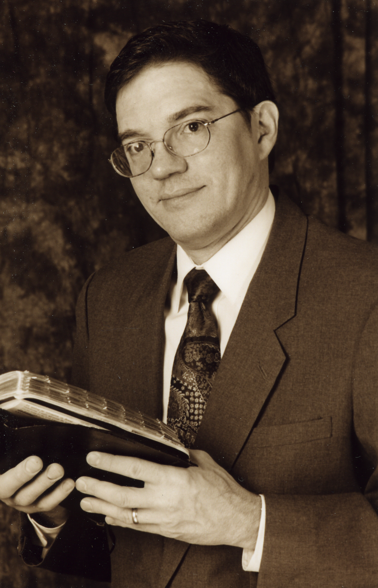
Deceived Deceivers………………..….1
Calendar Paganism………. ……...….5
JW Tricks………… ………………….6
Watchtower Pyramid………………....8
Answers in this Issue
This CHRISTIAN ANSWERS NEWSLETTER finds us dealing with a subject that is common to virtually all readers – Jehovah’s Witnesses, the perennial unwanted visitors to our doors. Requests for information about the Jehovah’s Witnesses is frequently to general topics apologetics ministries across the land and Christian Answers is no exception. Phone calls and mail requests have continued to flow in unabated since 1981 when I first began ministry in the counter-cult field. Concerned relatives and friends of those involved with Jehovah’s Witnesses make up the vast majority of our requests since actual JWs

THOUGHTS FROM THE DIRECTOR

CHRISTIAN ANSWERS NEWSLETTER

CHRISTIAN ANSERS MEWSLETTERS
Staff

Publisher
CHRISTIAN ANSWERS

Editor
Larry Wessels

CHRISTIAN ANSWERS
P.O .Box 144441
Austin, TX 78714
Fax/ Phone (512) 218-8022

Desktop Publishing & Design
Southwest Desktop Publishing
Jim Toungate, Jr.

Larry Wessels

for the most part steadfastly refuse to even look at what is termed “anti-Jehovah’s Witness” literature. In my own experience I have even had JWs refuse to look at their own Watchtower literature for the fear that I might show them something that may shake their confidence in their trusted “governing body” headquarters in Brooklyn, New York.
I’ve often said that the perfect false religion to learn how to refute as a Christian evangelist and apologist is the Jehovah’s Witnesses. More times than not, Bible verse for Bible verse, the JWs can twist, mangle, pervert and misinterpret more essential Christian doctrine than any pseudo-Christian cult I know (former Mormons may argue with me about that!). The JWs go wrong virtually every key doctrine from the Trinity, the deity of Christ, the personality of the Holy Spirit, the bodily resurrection of Christ, salvation by grace, and on and on the list goes.
The Watchtower Bible and Tract Society is a floodgate for heresy, both major and small. The Christian worker who studies JW beliefs and how to refute them from the Bible will find that he has prepared himself to deal with major heresy whether it comes from the JWs or a variety of other cults or pagan religions. The same or similar falsehoods found in JW teachings are also found in other cult religions (there are doctrinal patterns in the cults). The Christian evangelist who is willing to “study” to show himself approved (II Tim. 2:15) by learning essential Christian doctrine to refute JW heresy will happily find that he can also refute similar Mormon heresies, Unification Church heresies, Unity School heresies, and so forth.
“Witness oriented” Christians who are willing to learn Biblical doctrine more deeply and quickly can simply use the “contrast approach” to Bible mention above. I have that it is easier to “contrast” a false doctrine such as the denial that the Holy Spirit is God (a favorite JW doctrine) with the actual Biblical doctrine of the deity of the Holy Spirit (Acts 5:3,4: Gen. 1:2; 2 Cor. 13:14; Matt. 12:31-32; John 14:16-17), thereby making it easier for the Christian to see plainly the Bible verses that touch each key doctrine while correspondingly refuting the falsehood. In this way the Christian can assimilate essential Christian teaching in a quick and orderly fashion and be prepared to meet heresy whenever and wherever heresy rears its ugly head. II Tim. 3:14-17.
God bless you all.

The Gospel in Brief
There is one and only one, eternal, true God, almighty, all-knowing and good. He created everything be His word. God has told us the truth about Himself in the word He has given us, the Bible, which He commands us to obey. God is compassionate and just to all. God is pure and Holy; sin is destroyed in His presence. However, we have all sinned, falling short in the evil we do, the good we fail to do. Yet our problem is not just what we do, but also who we are; we are selfish, corrupt, and estranged from God. Because God is just, He will punish sin impartially, yet God still bestows His love to men. So our Savior, Jesus, the only begotten Son of God (The God-man, John 1:1, 14), was graciously sent to suffer and die on the cross for our sins and to purify us from all unrighteousness by the sacrifice of His body and blood. He was born of the virgin Mary, lived a sinless life, and was physically raised from the dead and ascended into heaven. Jesus will physically return to judge the world. God commands everyone to repent and believe in him. God’s Spirit lives in each of us who believes in Him to guide us into truth, convict us of our sin, and to work in us to sanctify us to live a more holy life, pleasing to our Lord. God’s children will dwell forever with God and those who reject Jesus will suffer eternal torment. There is no other way for anyone to come to God except through Jesus (Jn. 14:6). Please, do not depend on anyone else, your own efforts, your religion, but simply put your faith in Christ our Master. So, as Rom. 10:9 says, “That if you confess with your mouth, “Jesus is Lord,” and believe in your heart that God raised him from the dead, you will be saved.”
You are urged not to despise God’s mercy, but call out to the Lord and trust only in Him.
See also Acts 10:36-43

WHAT IS CHRISTIAN ANSWERS

Our ministry name is derived in part from 1 Peter 3:15 which states,” But in your hearts set apart Christ as Lord. Always be prepared to give an answer to everyone who asks you to give the reason for the hope that you have.” (NIV). This is the goal of CHRISTIAN ANSWERS in an increasingly anti-Christian society here in America and throughout the world.

The Biblical commands to “fight the good fight of faith” (1 Tim. 6:12), to be “set for the defense of the gospel” (Phil. 1:17), to “earnestly contend for the faith which was once delivered unto the saints” (Jude 3), to “be able both to exhort in sound doctrine and to refute those who contradict “ (Titus 1:9), to “ put to the test those who call themselves apostles, and they are not” (Rev. 2:2), to “Beware of the false prophets, who come to you in sheep’s clothing, but inwardly are ravenous wolves.” (Matt. 7:15), to “examine everything carefully; hold fast to that which is good’ (1 Thess. 5:21), “with gentleness correcting those who are in opposition, if perhaps God may grant them repentance leading to the knowledge of the truth” (2 Tim 2:25), to follow the example of Paul and Apollos who “vigorously refuted the Jews in public debate, proving from the Scripture that Jesus was the Christ.” (Acts 18:28) These are but a few of the marching orders for the call to ministry.

The inerrant Word of God (2 Tim. 3:16-17) whereby the gospel is preached, which is “the power of God unto salvation to every one that believeth” (Rom. 1:16), is the weapon or our evangelism. As Heb 4:12 states, “For the word of God is living and active. Sharper than any double-edged sword, it penetrates even to dividing soul and spirit, joints and marrow; it judges the thoughts and attitudes of the heart.” This is the evangelical missionary methodology of CHRISTIAN ANSWRS—to bring the Biblical perspective to a culture that is completely ignorant of it. To bring Christian truth, Christian answers to those who, as the prophet Isaiah said, have made “lies…and falsehoods” their refuge (Isa. 28:15). To smash lies and falsehoods with the “hammer” of God’s Word (Jer.23:29).

CHRISTIAN ANSWERS utilizes all outreach that God allows us including television, radio, audio cassettes, video tapes, speaking engagements, and printed page. The materials we have been able to produce have been used by churches, Bible teachers, Christian apologists, laymen and others as well as those seeking life in Jesus Christ.

We are not afraid to stand up for Jesus Christ in public forums or wherever the Lord leads. Of course this type of ministry is not for the faint of heart and very often leads to the same type of suffering and persecution that we find in the Book of Acts. But as the old sayings goes, “one life will soon be past, only what’s done for Christ will last,” and as Paul said, “I press toward the mark for the prize of the high calling of God in Christ Jesus.” (Phil. 3:14). Amen!

Our ministry is “exempt from federal income tax under section 501 (a) of the Internal Revenue Code as an organization described in section 501 (c) (3) by the Internal Revenue Service”. Donations to our ministry are tax deductible; therefore those who contribute will receive a donation receipt good on your US income tax. This applies to donations only, not sales. We are legally registered in the state of Texas.
2
(Continued from page 1)
Published by Bethany House Publishers, with complete documentation on this case and others); he stated that 97% of appendicitis cases are due to “biting of worms near the junction of the transverse colon with the small intestines” and a special medicine offered by the Watch Tower would solve the problem (The Watch Tower, Jan. 15, 1912). Despite Russell’s “inspired” teachings he later perjured himself under oath in the Russell vs. Ross “defamatory liable” case of March17, 1913 by first claiming to understand the Greek language in which the Bible was originally written.
Russell died on Halloween in 1916 and was succeeded by a Missouri lawyer named Joseph Franklin Rutherford who introduced the name, “Jehovah’s Witnesses” at a 1931 convention in Columbus, Ohio thus freeing followers from previous titles such as “Russellites”, “Millennial Dawnists,” and “Wathchtower people.” Rutherford carried on much of Russell’s belief in pyramids for most of his presidency as well as adding new beliefs and doctrines (such as devils could be saved, from Rutherford’s book Angels, p. 43, circa 1934).
Nathan H Knorr was the next Jehovah’s Witness president followed by Frederick W. Franz. Neither one of these men trained extensively in the original languages of the Bile. In fact, many Witnesses claimed that Franz was a Rhodes Scholar and a Scholar of Hebrew and Greek, but the Rhodes Scholarship Trust (Wesleyan University, Middletown, Conn. 06457) has stated that Franz was never considered for a Rhodes Scholarship; similarly a Scottish Court of Sessions of Nov. 1954, pp. 102, 103 in which Franz himself testified, made it clear that Franz could not read, speak nor translate the Hebrew language.
The Jehovah’s Witnesses claim to be the prophet of God for today as stated in their April 1, 1972 Watchtower magazine, page 197. The May 15, 1955 Watchtower says that the Jehovah’s Witnesses compromise Jehovah’s channel of communication. Many other publications proclaim that they are the only true religion. How do we test the claim of a so-called “prophet of God”? Deuteronomy 18:21-22 gives us the answer:

“You may say to yourselves, ‘How can we know when a message has not been spoken by the Lord?’ If what a prophet proclaims in the name of the Lord does not take place or come true, that is a message the Lord has not spoken. That prophet has spoken presumptuously. Do not be afraid oh him.”

Does the Watchtower speak for God? The Witnesses have set many dates for the End of the World and Armageddon (a bad habit they picked up from their founder C.T Russell and

qualified to translate the Bible. These men were: N.H. Knorr, F.W. Franz, A.D. Schroeder, G.D. Gangas and M. Henschel (write Personal Freedom Outreach, P.O. Box 26062, St. Louis, Missouri 63136 for documentation. P.F.O. is another excellent Christian Ministry well worth contacting).
A classic example of how the Jehovah’s Witnesses have perverted the Word of God is found in their NWT rendition of John 1:1. Since they deny that Jesus is God in the flesh they must change this verse and so they have. The NWT renders John 1:1 as: “In [the] beginning the Word was, and the Word was with God, and the Word was a God.” That is NOT what the Greek text says! Let’s take a look at what actual New Testament Greek scholars say about this:
1. Dr. Julius R. Mantey (who is even recognized by the Watchtower as a Greek scholar since they quote his book on page 1158 of their kingdom Interlinear Translation): calls the Watchtower translation of John 1:1 ‘the Word was a god.’ But of all the scholars in the world, so far as we know, none have translated this verse as Jehovah’s Witnesses have done.”
2. Dr. William Barclay (Univ. of Glasgow, Scotland): “The deliberate distortion of truth by this sect … ‘the Word was a god’, a translation which is grammatically impossible.”
3. Dr. Paul Kaufman (Portland, OR): “The Jehovah’s Witness people evidence an abysmal ignorance of the basic tenets of Greek grammar in their mistranslation of John 1:1.”
4. Dr. Robert H. Countess (Univ. of Tenn. And author of an excellent critical analysis of the NWT called The Jehovah’s Witness’ New Testament): “ There are 282 places in the New Testament where, according to the NWT should have translated ‘a god’ bit in fact they follow their own rules of ‘a god’ translation only 6% of the time. To be ninety-four percent unfaithful hardly commends a translation to careful readers!”
Lack of qualified Greek scholarship does not stop the Watchtower from citing support for their translation however. In many of their books and magazines over the years they have cited support from a New Testament translation by Johannes Greber (Aid to Bible Understanding, 1971 edition, pp.1669, 1134 is just one example). What the Watchtower fails to tell its followers is that Johannes Greber, the Lord’s Prayer (Matt. 6:9-10) begins like this: “Our Father in heaven, hallowed be Thy name. Thy Spirit-world come to us. Thy will be done in the

(Continued on page 4)

his Egyptian pyramid theories); for example, the Watchtower magazine, Sept. 12, 1922, p. 262 says: “The date 1925 is even more distinctly indicated by the Scripture than 1914.” Readers should reference further examples on page 5 of this news letter under the column, “…False Prophecies”. Jehovah’s Witness literature has predicted the end of the world in 1874, 1918, 1925, 1941, 1975, and even other dates. Has God been telling lies to His “prophet”?
The Watchtower Bible called the New World Translation of the Holy Scriptures and many of their so-called “authoritative” Bible aids and books are gross distortions of the actual Greek and Hebrew manuscripts on which the Word of God is based. The FORWARD of the New World Translation (abbreviated NWT), 1961 edition, page 5 says, “It is a very responsible thing to translate the Holy Scriptures from their original languages, Hebrew, Aramaic and Greek, in to modern speech… The translators who have a fear and love of the divine Author of the Holy Scriptures feel especially a responsibility toward Him to transmit his thoughts and declarations as accurately as possible.” These claims by the New World Bible Translation Committee raise some interesting questions: Have they been responsible? Have they rendered their translation as “accurately as possible”? According to the Watchtower Bible and tract Society (the headquarters of Jehovah’s Witnesses) over 34 million copies of the NWT has been printed as of 1981. Since that time, millions more have been printed and are being distributed through 5.8 million “publishers” (Jehovah’s Witnesses who are actively promoting Watchtower literature) throughout the world. In fact, another Watchtower book, The Truth That Leads to Eternal Life, according to the Guinness Book of World Records (1981 edition) is the third most published book of all time (with over 97 million copies in print, behind only the Holy Bible and Mainland China’s Quotations from the Works of Mao Tse-tung. This Truth book openly invites its readers to obtain a NWT, which first made its appearance in the early 1950’s but it has not heeded Jesus’ warning in Revelation 22:18-19 which says:
“For I testify to everyone who hears the words of the prophecy of this book: If anyone adds to these things, God will add to him the plagues that are written in this book; and if anyone takes away from the words of the book of this prophecy, God shall take away his part from the Book of Life, from the holy city…” (NKJV)
The Jehovah’s Witnesses have written a Bible based on their preconceived beliefs (such as their beliefs that Jesus is not God but rather Michael the Archangel). In fact, the men who comprised the Translation Committee were not even Greek

CHRISTIAN ANSWERS NEWSLETTER

3
substance (Heb. 1:3) and who took upon him flesh and blood and demonstrated for us God’s love and grace.”
Mark13:32 – The Jehovah’s Witnesses declare that Jesus could not be God since he did not know everything including the time of His return. The deceived Witnesses fail to take into account Philippians 2: 6-7 which stats that Jesus “who, being in very nature of God, did not consider equality with God something to be grasped, but made himself nothing, taking the very nature of a servant, being made in human likeness” (NIV). Jesus was complete God but also complete man and as the “Son of Man” He limited His divine attributes while depending on the Father and the Holy Spirit (see John 14:10, 12:49-50, 1:32-34, 17:5). Paul goes on to declare Jesus God in Phil. 2:10-11 by quoting from Isaiah 45:23 (“That unto Me (God) every knee shall bow, every tongue shall swear.”) then referring it to Jesus. Amen!
John 14:28 – “Ah”, says the Jehovah’s Witness, “this verse proves that Jesus is not God and is in fact inferior because his father ‘is greater than he’. Philippians 2 and other passages clearly show that while on the earth, Jesus “humbled himself” and was “made a little lower than the angels (Heb 2:9).” Therefore while Christ was here as a man, His position was lower than God the Father’s, thus His Father was “greater” that He. Better implies a difference in nature, quality, or essence. Greater denotes a difference in rank or position. Jesus Christ was so much greater than the angles (Heb. 1:4) since He had inherited a more excellent name, that is, by nature He was superior to the angels. God the Father called Jesus God in Heb. 1:8 and said for the angels of God to worship Christ (Heb. 1:6), an honor reserved only for God Himself (Rev. 19:10). Jesus by nature, being God is equal to God (John 1:1, 14 & John 5:23, John 14:1) but positionally, during His earthly time as a man, His father was “greater” than He.
The Jehovah’s Witnesses try to belittle Christ, but the truth is that people need to be pricked in their hearts, fall to their and cry out to Jesus, “My Lord and my God” just as doubting Thomas cried out in John 20:28.
“For false christs and false prophets will rise and show great signs and wonders to deceive… (Matt. 24:24)

(Continued from page
beyond and on earth (Greber p. 6) Greber’s spiritism is condemned by God’s Word in Deuteronomy 18:9-14, and elsewhere.
The NWT has deliberately distorted, changed added to and taken away key Bible passages that do not agree with what they already believe. In John 8:58 for example, Jesus declares that he is God by using the divine name of “I am” (see Exodus 3:14) and the Jews, realizing this, immediately try to stone Him (verse 59). The Witnesses do not like this so they have changed John 8:58 to read, “I have been” instead of “I am.” The list of intentional Bible distortions could go on and on (see also 1 Tim. 2:6; Acts 10:36).
Like their twisted Bible, the Witnesses twist Bible text to try to prove that Jesus is not God. They try to deny Christ’s deity with Rev. 3:14 – “the beginning of the creation of God,” Col 1:15 – “the first-born of all creation. “and John 14:28 – “my Father is greater than I” to name a few. An elementary study reveals that Jehovah’s Witnesses have misinterpreted the true meaning of these passages. For instance, in Rev. 3:14 “beginning” comes from the Greek word ARCHE which literally means the “first cause”. “origin”, or “source”. So Jesus did not have a “beginning” as the Witnesses say, but he was the “origin” or “source” of creation; Jesus was the architect (from the word ARCHE) of creation. He is God, the second person of the Trinity.
It is very important for Christians to become thoroughly grounded in the Word of God so the will not be led astray by false prophets and teachers. Churches should provide their people with strong teaching on essential Bible doctrine constantly as 1 Tim. 4:16 commands: “Take heed to yourself and to the doctrine. Continue in them, for in doing this you will save both yourself and those who hear you. (NKJV)”
The Jehovah’s Witnesses have “favorite proof-texts” (Bible verses which they like to use to “prove” their beliefs) that they use to confuse and confound opposers as well as convince those who are ignorant of Biblical truths. Since the chances of running into the Jehovah’s Witnesses or their literature is so high a study of some of their “proof texts” along with a Biblical refutation will help Christians to defend themselves and share Christ in the best tradition of Titus 1:9.
The Witnesses, in their passion to deny that Jesus Christ is God in the flesh, quote from a number of Bible verses. Among these are: Col. 1:15 – “the first-born of all creation,” Prov. 8:22, 24 – “The Lord possessed me… I was brought forth,” John 1:18 – “No man hath seen God at any time,” Mark 13:32 – “that hour knoweth no man… neither the Son,” and John 14:28 – “my Father is greater than I.” The preceding verses are used by self-confident Jehovah’s Witnesses to “prove” that Jesus could not possibly be God.

To them, anyone who does not agree with their interpretation is simply in “darkness and error.”
To escape “darkness and error” we need a light and that light is Jesus who has revealed his word through the Holy Scriptures. Have the Witnesses used scripture verses fairly or honestly to “prove their case? Not at all! Let’s back in their Biblical context and see what we get.
Col 1:15 – Here the Witnesses claim that Jesus was “first-born” in the sense that he was created by Jehovah God before anything else. Once again, the misunderstand the meaning of the original Greek. The Greek word for “first-born” is PROTOTOKOS meaning the heir to the family estate. It also denotes the one fist in rank or preeminence. If “first-born” meant the first one created like JWs say, then Paul would have used the Geek word PROTOKTISTOS rather than PROTOTOKOS. “First-born” signifies a preeminent position or title just as the Bible shows in Gen. 41:51-52 and Jer. 31:9 where Ephraim, although he was born second, was given the title of “first-born”! Jesus is the preeminent one of creation, he was before all things and he made all things. He is God the creator.
Prov 8:22,24 – The Jehovah’s Witnesses will usually refer to 1 Cor 1:24 (“Christ… the wisdom of God”) then cross-reference to this Proverbs passage. They say that Jesus is being referred to in Proverbs 8 as “wisdom” and therefore verses 22 and 24 “prove” that Jesus was created. Unfortunately for the Witnesses, they have forgotten some very important facts: there is nothing there is nothing in this passage which makes it Messianic; the Hebrew word translated “possessed” does not mean “created”; this passage is written in typical Hebrew poetic style indicating that the word “wisdom” is both impersonal and abstract; and Prov. 8:1-3 shows “wisdom” to be in the female gender which would bring the absurd conclusion that Jesus is female. The JWs have simply perverted this text to say something it does not say.
John 1:18 - The Witnesses assert that this verse is “conclusive evidence” that Jesus is not God because “no man hats seen God at any time” and people certainly saw Jesus. This “Scripture twisting” is easily overcome when one remembers the many Old Testament passages where God appeared to men in some visible form such as Gen 32:30, Gen. 18:1, Gen, 16:13, and Exodus 3:6 (see also Acts 7:2) John 1:18 concludes with “he (Jesus) hath declared him” meaning that whenever God who was visibly revealed. A pamphlet entitled “Straw Men of the Watchtower” by Personal Freedom Outreach states: “This is why Jesus could announce “He who has seen me has seen the Father” (John 14:9). Christ is God veiled in flesh (Phil. 2:6,7). Consequently while no man has seen God the Father (John 6:46) at time, there have been those who have seen God in the person of his Son, who is the vey image of God’s substance

CHRISTIAN ANSWERS NEWSLETTER

Conversation With Jehovah’s Witnesses

Larry Wssels debates two aggressive JWs at a university study center over the trustworthiness of the Watchtower Bible and Tract Society. This lively conversation revolves around JW teaching and prophecies. Wessels had been invited by the study center do deal with these particular JWs who had been causing turmoil among Christian students there. A rare recording of JWs on audio tape.

AC-11, 90 min., $5.95 + S&H
The JW’s New World Translation

Nationally known author and speaker James White carefully dissects the Jehovah’s Witness version of the Bible called The New World Translation and shows it to be a deliberate distortion. (Audio)
AC- 132, 90 min., $5.95 + S&H

1972 “So does Jehovah’s have a prophet to help them, to warn them of dangers and to declare things to come? These questions can be answered in the affirmative. Who is this prophet? … This ‘prophet’ was not one man, but was a body of men and women. It was the small group of footstep followers of Jesus Christ, known at the time as International Bible students. Today they are known as Jehovah’s Christian witnesses… Of course, it is easy to say that this group acts as a ‘prophet’ of God. It is another thing to prove it.” The Watchtower 4/1/1972 (see Deut. 18:21).

1889 “…the ‘battle of the great day of God Almighty’ (Rev. 16:14), which will end in A.D. 1914 with the complete overthrow of earth’s present rulership, is already commenced.” The Time is at Hand, p. 101 (1908 edition).

1897 “Our Lord, the appointed King, is now present, since October 1874, A.D., according to the testimony of the prophets to those who have ears to hear.” Studies in the Scriptures, Vol. 4, p.621.

1916 “The Bible chronology herein presented shows that the six great thousand-year Days beginning with Adam are ended, and that the great Seventh Day, the thousand years of Christ’s Reign, began in 1873.” The Time is at Hand, p. 2 (forward)

1920 “Therefore we may confidently expect that 1925 will mark the return of Abraham, Isaac, Jacob and the faithful prophets of old, particularly those named by the Apostle in Hebrews chapter eleven, to the condition of human perfection.” Millions Now Living will Never Die, P. 89.

1922 “The date 1925 is even more distinctly indicated by the Scriptures because it is fixed by the law God gave to Israel. Watchtower 9/1/1922, p. 262

1931 “There was a measure of disappointment on the part of Jehovah’s faithful ones on earth concerning the years 1914, 1918, and 1925, which disappointment lasted for a time. Later the faithful learned that these dates were definitely fixed in the Scriptures; and they also learned to quit fixing dates for the future and predicting what would come to pass on a certain date.” Vindication, volume, 1, p.338.

1941 “Receiving the gift, the marching children clasped it to them, not a toy or plaything for idle pleasure, but the Lord’s provided instruments for most effective work in the remaining months before Armageddon.
Watchtower, 9/15/1941, p.288.

1968 “WHY ARE YOU LOOKING FORWARD to 1975?”
Watchtower, 8/15/1968, p.494.

A FEW OF THE MANY FALSE PROPHECIES OF THE JWs

JEHOVAH’S WITNESSES:DECEIVED DECEIVERS

Director Larry Wessels takes the viewer on a tour of old Jehovah’s Witness literature revealing false prophecies, strange teachings and shifting doctrines in embarrassing detail. This series is very popular on cable television.

VHS, VT- 38, 4 hrs., $25 + S&H
Audio tapes available: Entire series ES- 14,
$17 +S&H Single tapes AC-213-216, $5.95 each.

CALENDAR PAGANISM

Jehovah’s Witnesses refuse to celebrate holidays, particularly Christmas and Easter, because of the pagan origins of said holidays. The JWs cite Easer as a pagan rite with roots in Babylon and the goddess Astarte, with the word itself being derived from the Norse Ostara or Eostre. The JWs tie Christmas and the date December 25 with the ancient Roman holiday of Saturnalia which involved tribute to the pagan god Saturn (the god of agriculture).
Jehovah’s Witnesses fail to realize that old words can have new meaning and therefore no paganism is involved. Easter is celebrated by Christians as the resurrection of Christ while Christmas is the celebration of Christ’s birth. Christ alone is celebrated not ancient deities.
If the JWs followed their own logic in “paganism avoidance” then they would refuse to use or honor calendars as well. Hypocritically, however, JWs use calendars which have their origins in paganism.

DAYS OF THE WEEK
- Sunday- Sun’s day (sun god)
- Monday- Moon’s day (moon god)
- Tuesday- Mar’s (Tues in Norse) day
- Wednesday- Mercury’s (wodan’s) day
- Thursday- Thor’s (Jupiter’s) day
- Friday -Venus’ (Frigga’s) day
- Saturday- Saturn’s day (Greek: father of Zeus) source: The Lincoln Library of Essential Information, p. 12. see also The Columbia Viking Desk Encyclopedia, p. 1450.

MONTHS
- January- Named after the Roman god Janus (deity of the gates)
- February- Sabine festival of purification called Februa
- March- Named after the Roman god mars (god of war)
- April- Aphrodite/ Venus (goddess of love)
- May- Named after the Italian goddess Maia
- June- Named after the Roman goddess Juno
Source: New Edition – The American Heritage Dictionary of the English Language

Apparently the JWs do not live up to their own standards, the very standards which they demand of others!

Common JW Literature

CHRISTIAN ANSWERS NEWSLETTER

Examining The New World Translation

Did the Jehovah’s Witnesses do a reliable job in translating their version of the Bible from the original languages? Dr. Sam Reed, who holds a Ph. D in Biblical languages from the University of Texas, analyze the JW bible in light of the original Greek and Hebrew. Dr Reed is joined by Jackson Boyett and Larry Wessels. “It is all Greek to Me John 1:1” by Dr. Reed is also included in this video presentation

VHS, VT-62. 1 ½ HRS, $15 +S&H
Audio soundtrack: AC-231, 90 min. $5.95 + S&H

Evidence that Jesus is God

Author James White and Larry Wessels reveal key scriptural texts to prove that Jesus is God in the flesh in contrast to Jehovah’s Witness doctrine.

VHS, VT-36, 1hr, $12 + S&H
Audio soundtrack: AC-147, 60 min., $5.95 +S&H

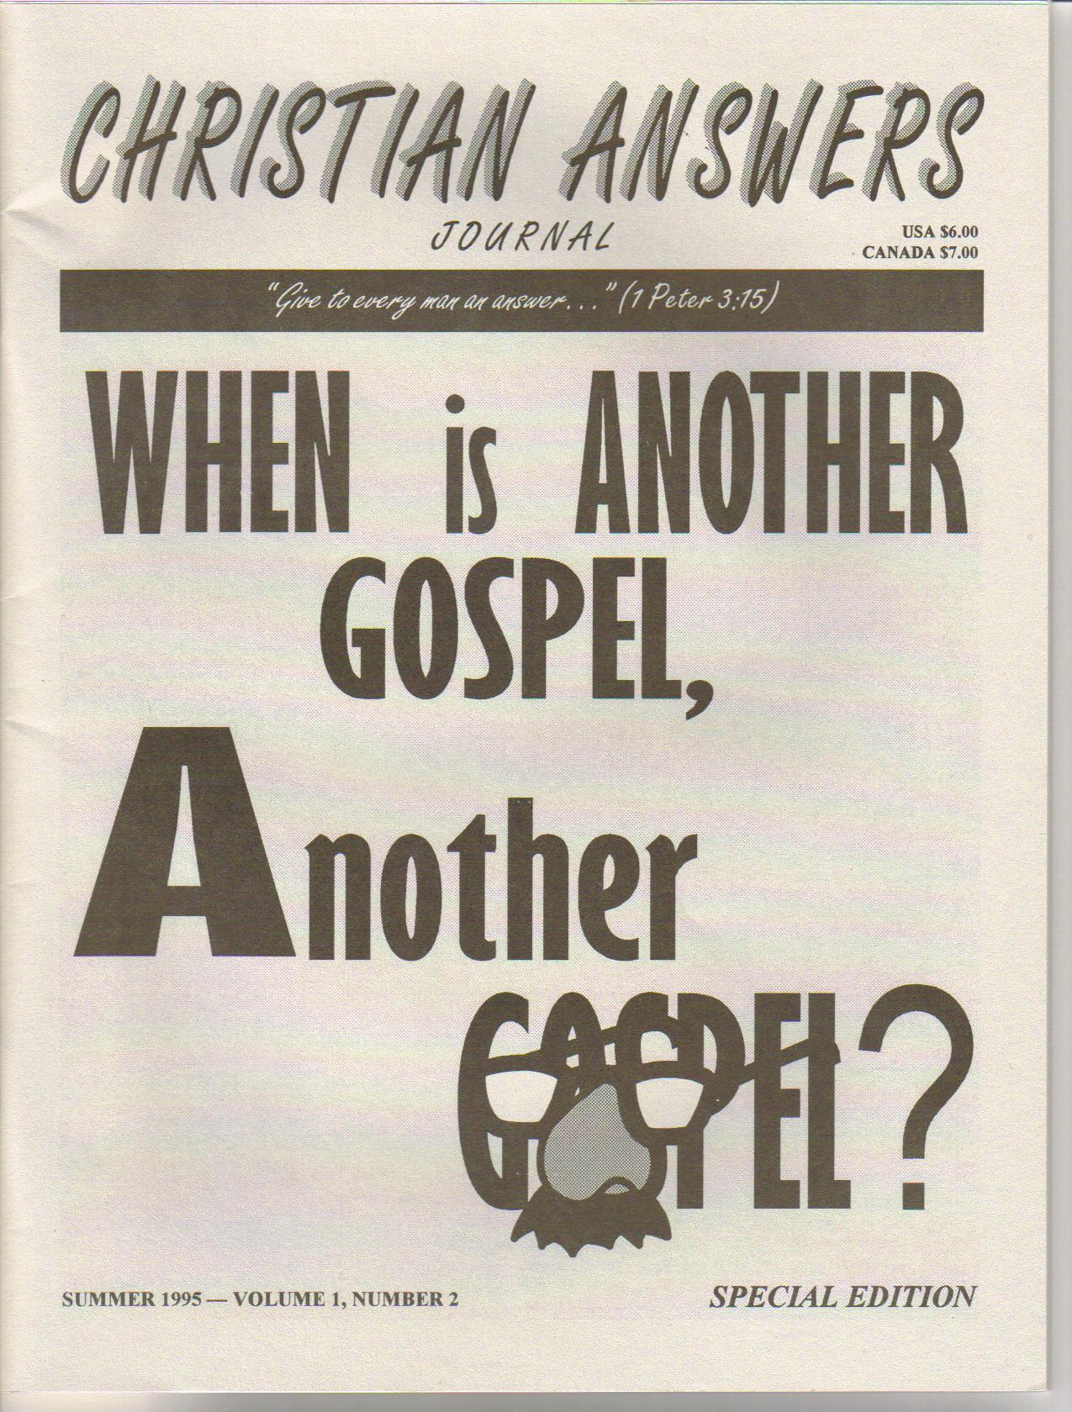

Need further in-depth information? Obtain the 48-page CHRISTIAN ANSWERS JOURNAL which contains:

1. When is Another Gospel, Another Gospel? by Rob Zins
2. An Open Letter from Wilson Ewin
3. The Roman Catholic Church in History by Jim Toungate Jr
4. Cultic Definitions by Larry Wessels
5. Surprised by Truth by James White

This journal also includes:
1. The Major Errors of Campbellism by Bob L. Ross
2. The Many Faces of Hinduism by Steve Morrison
$7.00 + S&H, CAT. # CAJ-2

Attention: Cable Access Producers

Christian Answers is looking for a few good cable access producers. Our director Larry Wessels has been a local cable access producer for more that ten years and has found this media outreach an inexpensive opportunity to get the Christian message out to the local secular community.
Christian Answers has videos on a wide rang of subjects that were originally produced as local cable access television shows. Please see the Christian Answers resources list and catalog for a complete listing of all the topical videos available to date.
If you desire to reach your community (provided they have cable access television) with informative Christian Answers videos that can help those with sincere questions, please contact Christian Answers. Call (512) 218-8022 and leave your name and mailing address and we will send you a cable access producer form letter which will instruct you of the steps to take next. You can write us as well in this regard. Make an impact in your town for Christ!

Christian Answers
P.O Box 144441
Austin, TX 78714

5
How JWs Trip Up
Naive Christians
1. The dead do not ascertain by seeing anything under the sun anymore.
2. Whatever knowledge and experience they may have learned, the knowledge is lost under the sun, for they cannot pass it on.
3. As in verse 5, the (spiritually and physically) dead have no hope and no knowledge of a future state. Even the wicked on this earth can have hope of being saved while they still breathe the air under the sun.
4. The dead know of no reward. As in Job 14:21, the dead have no knowledge of honor or dishonor paid to their memory. They do not know how soon they are forgotten.
The JW heresy of non-existence (“soul sleep”), based on out of context passages from Ecclesiastes and elsewhere, is refuted by such passages as Phil. 1:23, 2 Cor. 5:1-8, Mark 12:26, Ecc. 3:21, 12:7, Acts 7:59-60, and Luke 23:46

DOCTRINAL TRAITS OF JWs
JWs cannot be accused of being too devoted to Christ since they do not believe he is God.
The Apostles were completely devoted to Christ, see 2 Cor. 11:2-3, John 5:22-23, Gal. 6:14 and 1 Cor. 2:2

JWs deny the bodily resurrection of Christ. The Apostles believed that the resurrected Jesus had a physical body. See John 20:24-28, Phil. 3:21, Col.2:9 and Luke 24:36-43.

JWs are inconsistent if Jesus is their Lord. See John 20:28-29, Isa. 7:14, 45:18, 21.

JWs do not honor Jesus like the Father.
See John 5:22-23 and Rev. 5:12-13

The Holy Spirit does not live in JWs according to their doctrine. See Romans 8:9-11, 16, 26 and John 14:17.

JWs do not believe Christ is inside them.
See 2 Cor. 13:5, Gal 4:6 and John 14:23.

The Watchtower teaches that most JWs will not be with Christ worshipping Him
See 2 Cor. 5:8, Heb. 1:6, and Rev. 5:12-13.

A point to remember –
If a person follows the wrong god, wrong Jesus, and the Holy Spirit does not live within him, then at the last judgment what he believes will not save him (2 Cor. 11:4, Rom. 8:9 and II Peter 2:1-4). JWs doctrine is anti-Biblical and anti-Christ and should be resisted by the people of God. (Gal. 1:6-9).

CHRISTIAN ANSWERS NEWSLETTER


The first meaning is Jehovah God, the only one to worship, and the second meaning is a great and powerful person. We may call Jesus god, but only in the second sense.
CHRISTIAN: Multiple meanings of the word “god” does not prove there are only two meanings: there are actually three. The widest sense is a perceived powerful being, a so called god as in 1 Cor. 8:5 and John 10:35. The narrowest is God the Father (Col. 1:3 and Eph. 1:3). The middle meaning of Jesus (and the Holy Spirit) is in John 1:1, 20:28-29 and others. Jesus Himself shows He is God in more than the widest meaning in John 10:36 and John 5:22-23. Biblical context of the deity of Christ destroy the JW argument. See Titus 2:13, I Tim. 3:16, II Cor. 5:19, and I John 5:20 for openers then compare how Christ is given the same titles as God the Father i.e. Creator, John 1:3, Col. 1:16-17; First and Last, Rev. 1:17 cf. Isa. 44:6; Lord of Lords, Rev. 17:14 cf. Deut. 10:17, and the I AM, John 8:58 cf. Ex. 3:14.

JW: Since Rev. 16:3 says in Greek the “souls” in the sea died referring to the sealife, therefore, soul means life, and man does not have a “soul” separate from his body any more than an animal does.
CHRISTIAN: Aboard the ark, 1 Pet. 3:20 in Greek says only eight “souls” were saved. Soul sometimes means “life” as in Rev. 16:3, and sometimes it means the spiritual part of a Christian that is present with the Lord when we are absent from the body as in 2 Cor. 5:8. Notice that we do not have a body at this point, but are “absent from the body.” 1 Pet 3:20 shows that only people (not animals) have savable souls.

JW: Ecc. 9:5-6 and PS. 6:5 state that people are unconscious and non-existent at death, because “the dead know nothing”?
CHRISTIAN: Ecclesiastes tells of life under the sun, and its meaninglessness without God. The Hebrew word for “know’ in Ecc. 9:5-6 “yada”, is interesting in that it has a wide range of meaning. According to Strong’s Concordance, it means to know by seeing; but it can also be used in figurative, literal, and/or a euphemistic sense. It can refer to “instruction, designation, punishment, acknowledge, acquaintance (acquainted with), advise, answer, appoint, assuredly, be aware, etc.” Other interesting synonyms are “declare, instruct, tell, and feel.”
Of the various words for know, this word is highly appropriate here, because “the dead know nothing” in at least four ways.

Steve Morrison

I

“…holding fast the faithful word which is in accordance with the teaching, that he may be able both to exhort in sound doctrine and to refute those who contradict.” Titus 1:9

Here are some common approaches Jehovah’s Witnesses use with Christians. Christian answers follow.

JW: The word Trinity is not in the Bible, so it is not Biblical.
CHRISTIAN: The word Trinity, Old and New Testament, rapture, missions, and discipleship are just a few of the commonly used terms not found in the Bible. Merely giving labels to Biblical concepts does not make them any more or less true. The word Trinity is a simple way to describe the God-head as found in Matt. 28:19 II Cor. 13:14…

JW: Jesus is less than the Father according to 1 Cor. 11:3, Matt. 24:36, and Phil. 2:7-8.
CHRISTIAN: Of course Jesus was less than the Father when He was on earth as a man. In heaven, he is equal to God the Father in nature, glory, honor, and other things. JWs try to degrade Jesus. The JWs play on the human aspect of Jesus while forgetting his deity (Jesus is God, see John 1:1, 14, Col. 2:9, Romans 9:5, Heb. 1:6-8, John 20:28, etc.). How does a JW interpret John 5:23, “all may honor the Son just as they honor the Father.” (NIV)?

JW: Saying Jesus is less than the Father, in any way, contradicts the Trinity.
CHRISTIAN: If you misunderstand the Trinity, or find others who are ignorant, that detracts nothing from God’s truth. From Tertullian, who was one of the first to use the word Trinity, to the NIV Study Bible (note on 1 Cor. 11:3) Christians have taught that Jesus was equal in nature, yet the Father is His head (John 5:26, Matt. 28:18, Phil. 2:9).

JW: God is the head of Christ (1 Cor. 11:3).There is only one True God (Deut 6:4 and 1 Cor. 8:6), yet there are many gods (1 Cor. 8:5 and John 10:35-36. There are two meanings of God in the Bible.

Christian Answers Information pack-17:
Jehovah’s Witnesses
A valuable information package of numerous articles and tracts dealing with JWs on a wide range of issues. Everything from JWs and blood transfusions to Watchtower doctrines concerning lying and hating and included.
Pack- 17, $6.00 + S&H

6

TRAPPED IN THE JEHOVAH’S WITNESSES

CHRISTIAN ANSWERS NEWSLETTER

Christian Answers Director Larry Wessels (left) with Audrey Kaufman and children Stacy, Jason and Jerret.
TOPICAL VIDEOS

Audrey Kaufman, mother of three, lost custody of her children to her ex-husband who later became a Jehovah’s Witness. Audrey gives her personal testimony of her battle to regain her children and consequently free them from the Jehovah’s Witness lifestyle. The children tell their story of what it was like to grow up in the Jehovah’s Witness environment, such as:
1. At school, JW children cannot partake in extra-curricular activities with non-JW children.
2. JWs do not celebrate holidays.
3. JW youth should spend their time going door to door distributing Watchtower literature.
4. The JW child’s “goal” in life should be pioneering (missionary work), not careers.
This timely video is useful to Christian apologists and those who have friends and relatives “trapped” in the Jehovah’s Witnesses. Join Audrey as she takes the viewer on a heart-felt journey from despair to triumph.
Hear experts in their field analyze these topics (perfect for study groups). You may choose any four of the 28 minute videos below for the single price of $20.00 + S&H. Catalog identification is CATV. For example, if you wish to order Bahaism, “Church of Christ”, United Pentecostal Church, and Mormonism; please list on order form as CATV = 1, 8, 9, 12. Four videos on one tape for one low price of $20.00 + S&H.
1. Bahaism (Dr. Frank Beckwith)
2. Roman Catholicism #1 (Rob Zins)
3. Roman Catholicism #2 (Rob Zins)
4. The “King James Only” cult #1 (Gary Hudson)
5. The “King James Only” cult #2 (Gary Hudson)
6. Seventh-Day Adventism #1 (Wallace Slattery)
7. Seventh-Day Adventism #2 (Wallace Slattery)
8. The “Church of Christ” (Bob L. Ross)
9. United Pentecostal Church (Mark McNeil)
10. Word-Faith Heresy #1 (Michael Horton)
11. Word-Faith Heresy #2 (Michael Horton)
12. Mormonism (Robert McKay)
13. Jehovah’s Witnesses #1 (Larry Wessels)
14. Jehovah’s Witnesses #1 (Larry Wessels)

If you have friends who might be interested in being on the Christian Answers mailing list, please enclose their names and addresses with your order or correspondence. A free newsletter will be sent to them at your request.

VHS, 1 ½ hours, VT-37, $12.00 + S&H .
Audio soundtrack also available – AC- 98, $5.95 +S&H

Special Purchase Incentive: If you order more than $50.00 worth of material you may choose two of the following audio tapes to be enclosed with your order free
(Check preferences): Jehovah’s Witnesses (AC-49) Evidence that Jesus is God (AC-147) Doctrinas de los Testigos de Jehova (AC-152)

Description

Quantity

Total

Unit Price

IF YOU NEED MORE ROOM PLEASE USE A SEPRARATE SHEET OF PAPER
How to place an order with CHRISTIAN ANSWERS
1. Please indicate your full shipping/mailing address.
2. Please include quantity, description and price (minimum- order -$5.00)
3. Please make check or money order payable to CHRISTIAN ANSWERS (we can only accept US funds).
4. Mail to: CHRISTIAN ANSWERS, P.O. Box 144441, Austin, TX 78714
5. Foreign orders must be paid with an international money order (US funds only). Charges are extra for foreign air mail.

CHRISTIAN ANSWERS ORDER FORM
SUBTOTAL

Postage & Handling

Texas Residents Add 8.25% Tax Tax

Tax deductible donation
TOTAL

7
Up to $30.00 $2.00
$30.01 to $50.00 $3.50
$50.01 to $75.00 $5.00
$75.01 to $100.00 $7.00
$101.00 and up 8%
Foreign orders 20%
PLEASE ALLOW 2 TO 4 WEEKS
FOR DELIVERY.

NAME: .
ADDRESS: .
CITY: .
ZIP CODE: STATE: .
PHONE #: ( ) VISA: ( ) or MC ( ) check one
Credit Card No. . Exp. Date .

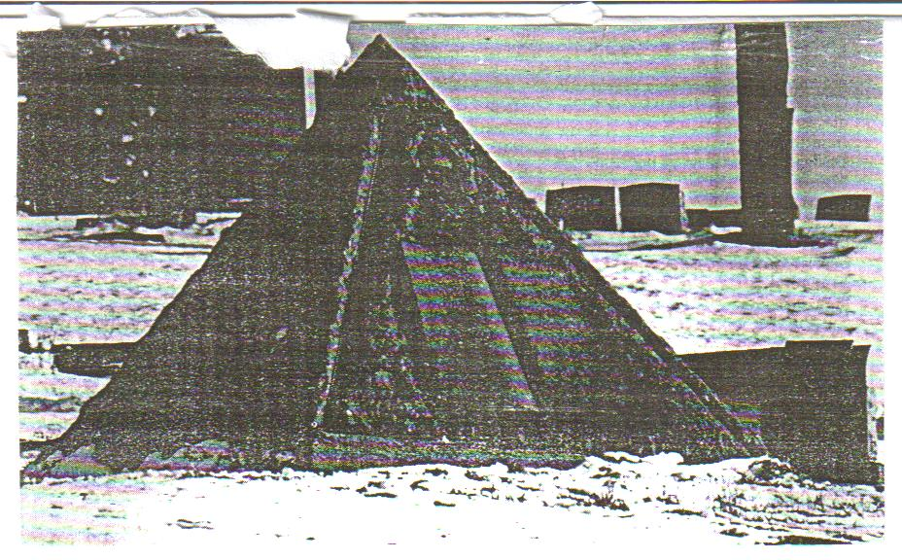
Dear Christian Answers,
Thank you for the information that you sent on your ministry, the resources and the issue of your news letter. I really enjoyed the information. I will tell other people about our ministry and will support your ministry in my prayers and financially if when possible.
I also thank you for all the debates that you have, and to ask you to keep me informed about further debates. Thank you again for what you have sent me and please keep me informed of further things.
May God bless your ministry.
In His love and service,
J. D.
Glen Burnie, MD
Dear Christian Answers,
I wanted to write to tell you what happened to me. I had always been an “intellectual” who believed that man could save himself. Oh, I believed in God, but it was a belief I created to fit my idea of how I wanted the world to be. Now being the intellectual type of I read a lot and was very open minded. After watching “In Defense of the Faith” one night, I realized I had been avoiding the Bible. So I began to read some chapters. The more I read the more scared I was. I began to see that the Bible showed me I might be wrong. In other words I came to an intellectual stopping point. I could not refute or explain away God’s word any longer. My world came crashing down and I felt so confused. Now in the Bible there were instructions for people in my situation. So I prayed. I said “God – show me who Jesus is”. I don’t have to tell you what happened next, do I?
Now that I am saved, I know I must live my life like God wants me to. I am trying. I have confessed and I am reading the Word. I have accepted Jesus as my Savior and I am attending church tonight for the first time since I was a little boy. My friends think I’m crazy and when they remind me that I am a person who used to laugh at Christians, I say, “that was then, this is mow!”
Why am I writing? I really don’t know, except to than you all for your help and I just wanted to tell you what happened. Dale said, “read the Bible.” Larry (who is very good at keeping on course) said, “read the Bible.” David said, “Don’t believe me, believe what God said!”
Well guys – I did! And I do!

God Bless you all,
J.H.
Austin, TX
LETTERS FROM THE FRONTLINE
CHRISTIAN ANSWERS NEWSLETTER



The Watch Tower Pyramid

The Watch Tower Society burial lots in Rosemount United Cemeteries, Pittsburg. PA. A stone pyramid engraved with a cross, dedicated by the Watch Tower Society, stands guard over the graves of Watch Tower faithful including its founder Charles Taze Russell.

Dear Christian Answers,
I saw your show today and could not turn away. I have been praying for help and I believe your show was the answer. [Austin cable access show] My problem is my mother-in-law is a Jehovah’s Witness and has been all of her life. My husband is no longer a Jehovah’s Witness, but does not feel that any other religion is right, either. She would love to bring him back and bring me with him.
I have learned that although I was raise in a Christian church (Southern Baptist) and have been a Christian form many years, I know what I believe but not why. I have been studying their Reasoning from the Scriptures (1985, 1989) and comparing this to what my Bible says (KJV, NIV), but was having trouble trying to prove Jesus’ deity and the Trinity. You and Your Guest, James White, gave some wonderful hints. [CA video VT-36]
Please send information on how to witness to a Witness. God Bless You,
M. H.
Austin, TX

Since 1970 the Jehovah’s Witnesses have grown by 162% in America. During the last quarter of the 20th century, the country’s fastest growing religious communities have been Pentecostal, Mormon and Jehovah’s Witnesses.

Please write Christian Answers for a free resource list. The current list contains approximately 60 videos. 300 audio tapes (including radio shows), and books.

“Give an answer to every man…” 1 Peter 3:15
Inside This Issue:
Topic: Mormonism

Page 1: Is Mormonism A Cult?
Page 2: Thoughts from Director
Page 3: LDS Tricks
Page 5: Mormonism video Series
Page 6: Mormon Pageant
Page 8: Letters from the Frontline
CHRISTIAN ANSWERS
P.O. Box 144441
Austin, TX 78714
Phone (512) 218-8022

U.S. POSTAGE

